**Programming Principles HW03**

**Student Name: 游忠敏 Student Number:11619370216 Due:2018.11.14**

* **2.38**

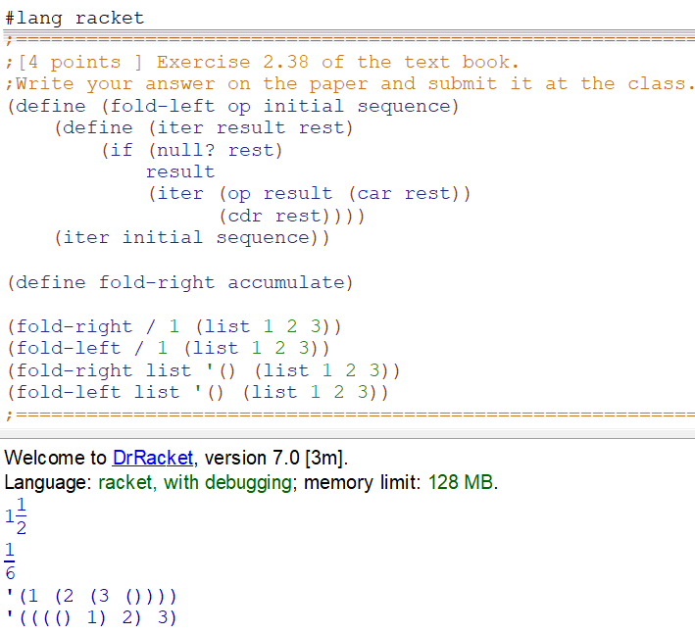

Figure 1. result of codes running.

1. (fold-right / 1 (list 1 2 3))

(/ 1 (/ 2 (/ 3 1)))

(/ 1 (/ 2 3))

(/ 1 2/3)

3/2

1. (fold-left / 1 (list 1 2 3))

(/ (/ (/ 1 1) 2) 3)

(/ (/ 1 2) 3)

(/ 1/2 3)

1/6

1. (fold-right list '() (list 1 2 3))

(list 1 (list 2 (list 3 '())))

(list 1 (list 2 (3 '())))

(list 1 (2 (3 '())))

(1 (2 (3 '())))

1. (fold-left list '() (list 1 2 3))

(list (list (list '() 1) 2) 3)

(list (list ('() 1) 2) 3)

(list (('() 1) 2) 3)

((('() 1) 2) 3)